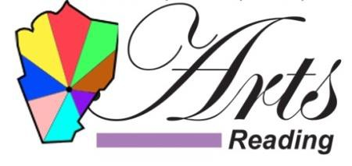

Annual Membership Application

Arts Reading is proud to enhance and sustain the vibrancy of Reading by fostering local cultural development.
Your personal or organizational involvement and membership dues directly support our cultural events, membership directory and the long-term goal of building a cultural district in our community. If you have any questions about membership, our events, calendar or directory please email ArtsReadingMA@gmail.com

THANK YOU FOR YOUR SUPPORT!

Name/Organization: ____________________________ Email: _____________________________
Address: ______________________________________ Website: ___________________________
City, State, Zip: _____________________________________________________________________
Contact Name: _________________________________ Phone: ____________________________

MEMBERSHIP PLAN: Organizational: (voting member, directory listing)  $50

Individual: (directory listing)  $25

Donation:  $ ________
(Any Amount)
PAY ON-LINE: Please go to the bottom of our Membership Page to pay on-line at:

ArtsReadingInc.org
___________________________________________________________________________

GET INVOLVED!  Leadership /Officer Role
Ask us about some minor roles that  General Event Planning
will also assist you to your advantage!  Fundraising
❑ Website and Marketing
❑ Other ________________________

❑ Please include my information in the Arts Reading Directory – ArtsReadingInc.org
❑ Check enclosed
❑ Paid On-line Date ___________

PAY BY CHECK: Make check out to: Arts Reading Inc.

and mail to: Ricky Corbett, Director
261 Washington Street
Woburn, MA 01801

___________________________________________________________________________

Office Use: ___Rec ___Dep ___Ack ___Directory 04222022

About Arts Reading

MEMBERSHIP INFORMATION:

CULTURAL ORGANIZATION: Established Professional Cultural Organizations who have a shared interest in culture for the Town of Reading. Each organization may only have one voting representative at an Arts Reading meeting.

INDIVIDUAL: Individuals dedicated to arts and culture. They are admitted into Arts
Reading by paying annual dues. They may attend meetings but do not vote.

PATRON/SPONSOR: Individuals wishing to contribute to the arts and promote the cultural resources in the Town of Reading.
They may attend meetings but do not vote.

SHORT TERM GOALS

- Recruit partners and supporters.
- Increase cultural programming and entertainment in downtown.
- Highlight historic and other cultural assets.
- Create a master calendar/posting site to promote cultural events
(Perhaps combined with downtown entertainment, shopping, and dining guide.)
- Increase utilization of existing venues

LONG TERM GOALS

- Explore options for creating zoning and financial incentives for art related uses.
- Create strategy to recruit creative economy businesses to downtown
- Create art and cultural center facility or district
- Apply for MCC designation as a cultural district
- Provide infrastructure improvements supportive of cultural district and events such as way finding signage, social gathering/seating areas and public venue improvements.

