Historical ~ Musical ~ Visual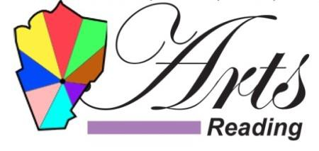Literary ~ Theatre ~ Community

Fundraiser to Benefit Arts Reading, Inc.!
Our Members:
Ivy Chord Coffeehouse, Colonial Chorus Players, Everett and Ginny Blodgett, Nora Bucko, Heather Gay, Whitelam Books, Joe Leto, Jr., Quannapowitt Players, Inc., Reading Historical Commission, Reading Public Library, Town of Reading, The Music Porch, Northeast Youth Ballet, Creative Arts for Kids, CATO Coalition of Us, Reading Symphony Orchestra, and Rick Corbett Art.
WHEN: September 16, 2022
WHERE: MANDARIN READING, 296 Salem Street, Reading, MA 01867
TIME: 11:30 AM-9:30 PM
Go to our website and download a coupon to present to your server. 20% of your bill will be donated to Arts Reading.
The coupon is good for both dine-in and take-out.
Visit our website, www.artsreadinginc.org and “Like” our Facebook page, www.facebook.com/ArtsReadingMA.

